QR Codes of Policy Documents

1 | National Adaptation Plan (NAP)  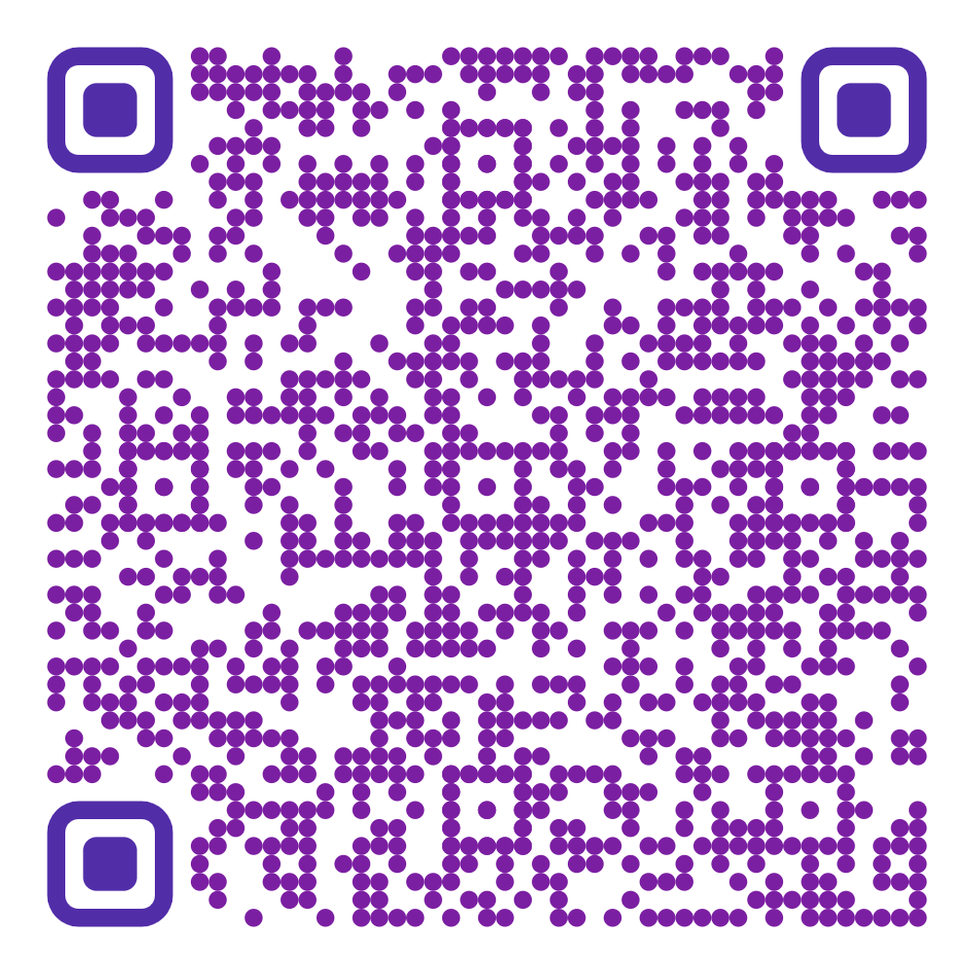
2 | National Clean Air Policy (NCAP)  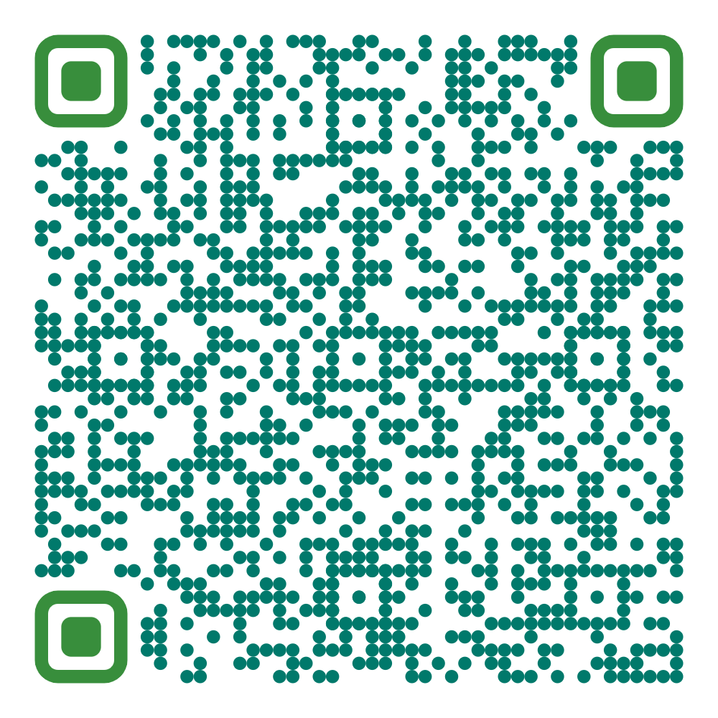
3 | Pakistan Updated Nationally Determined Contributions 2021  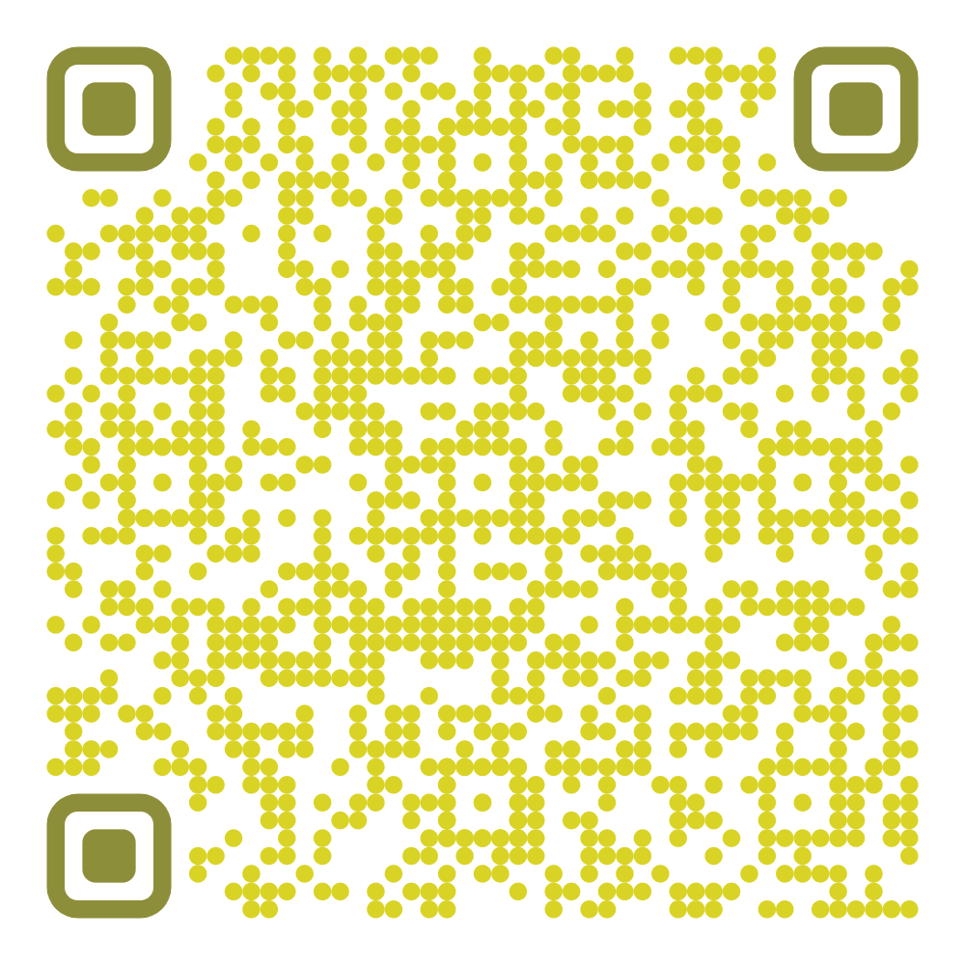
4 | National Hazardous Waste Management Policy 2022  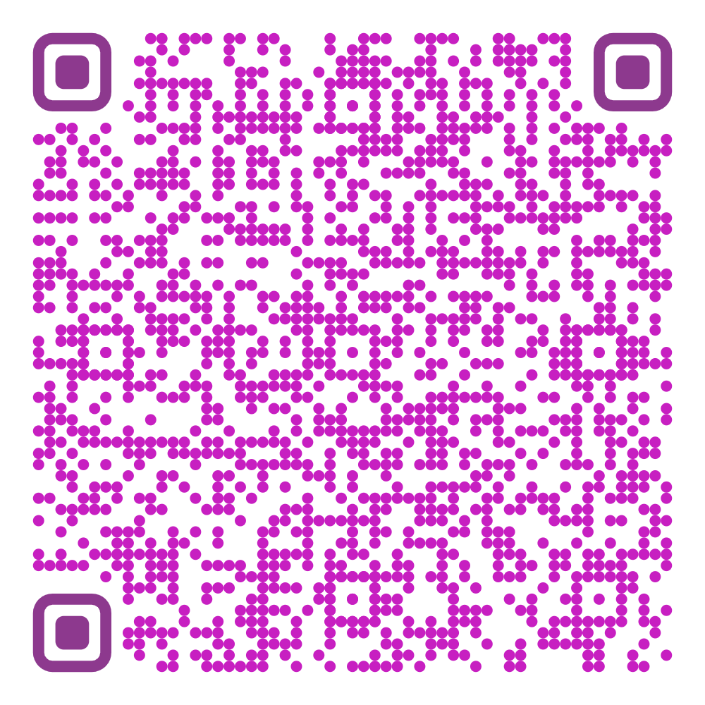
5 | National Electric Vehicle Policy (2019)  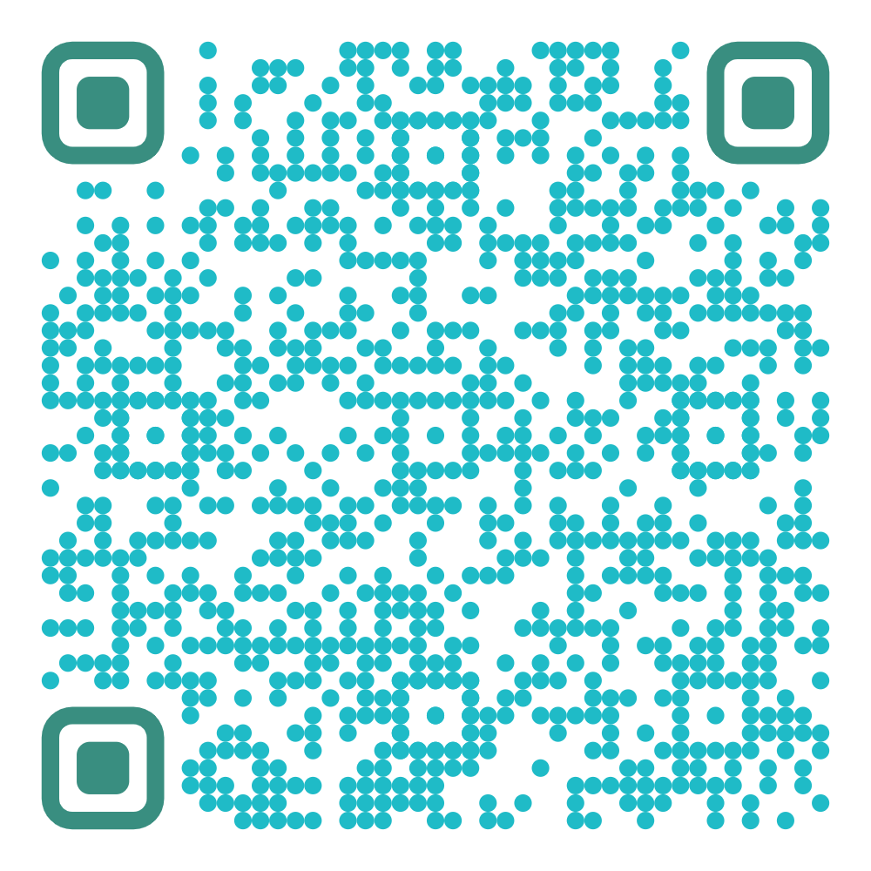
6 | Final Updated National Climate Change Policy-2021  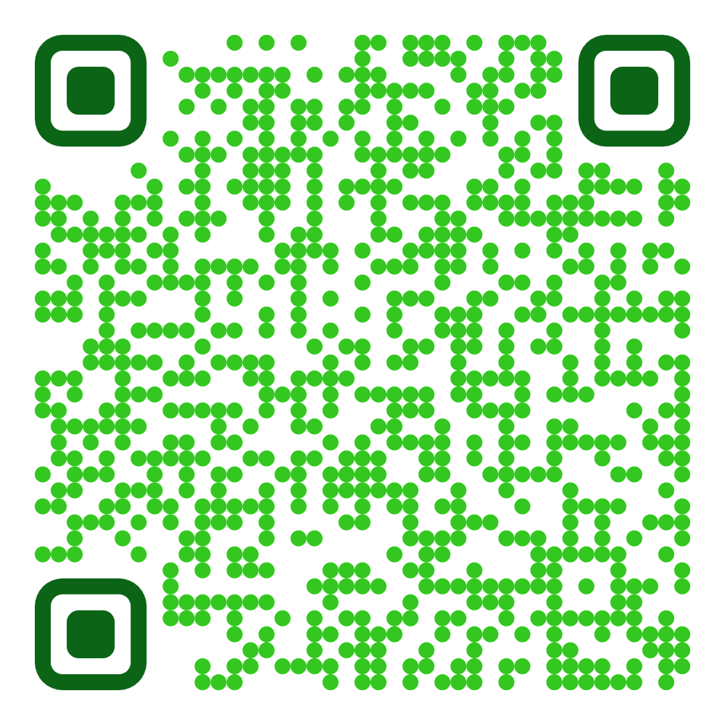
7 | National Forest Policy  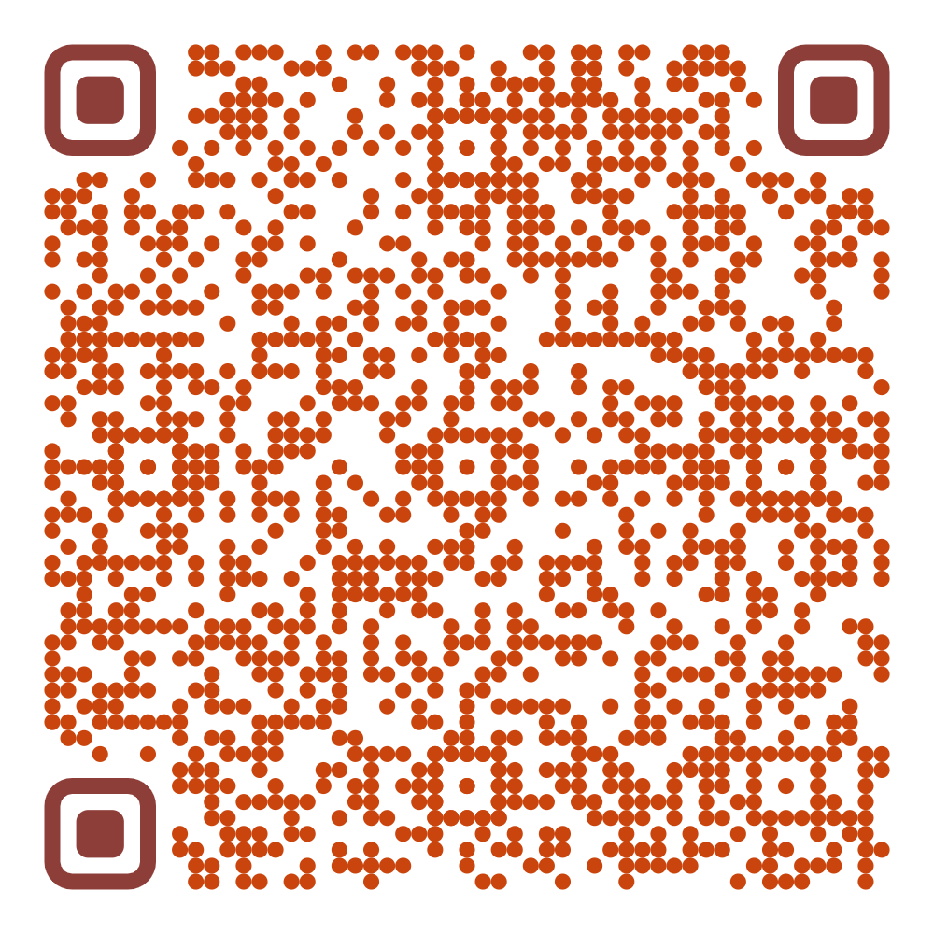
8 | National sanitation policy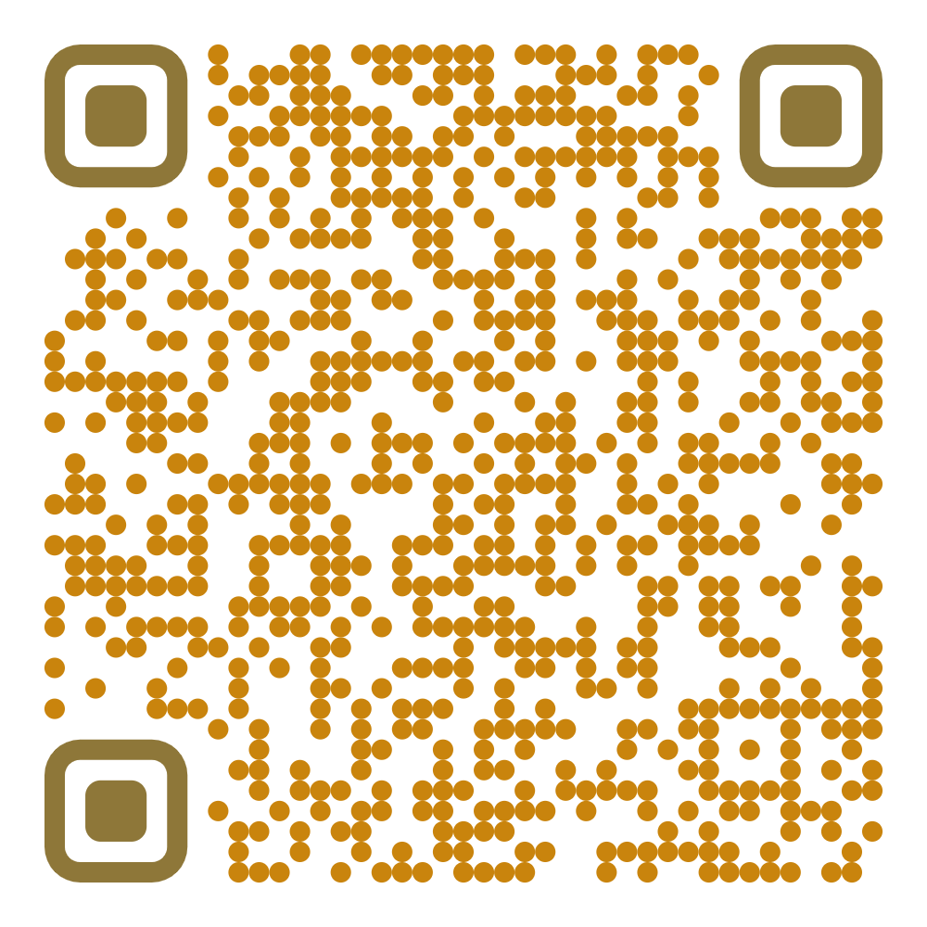
9 | Pakistan Biennial Report (BUR1) submitted to UNFCCC  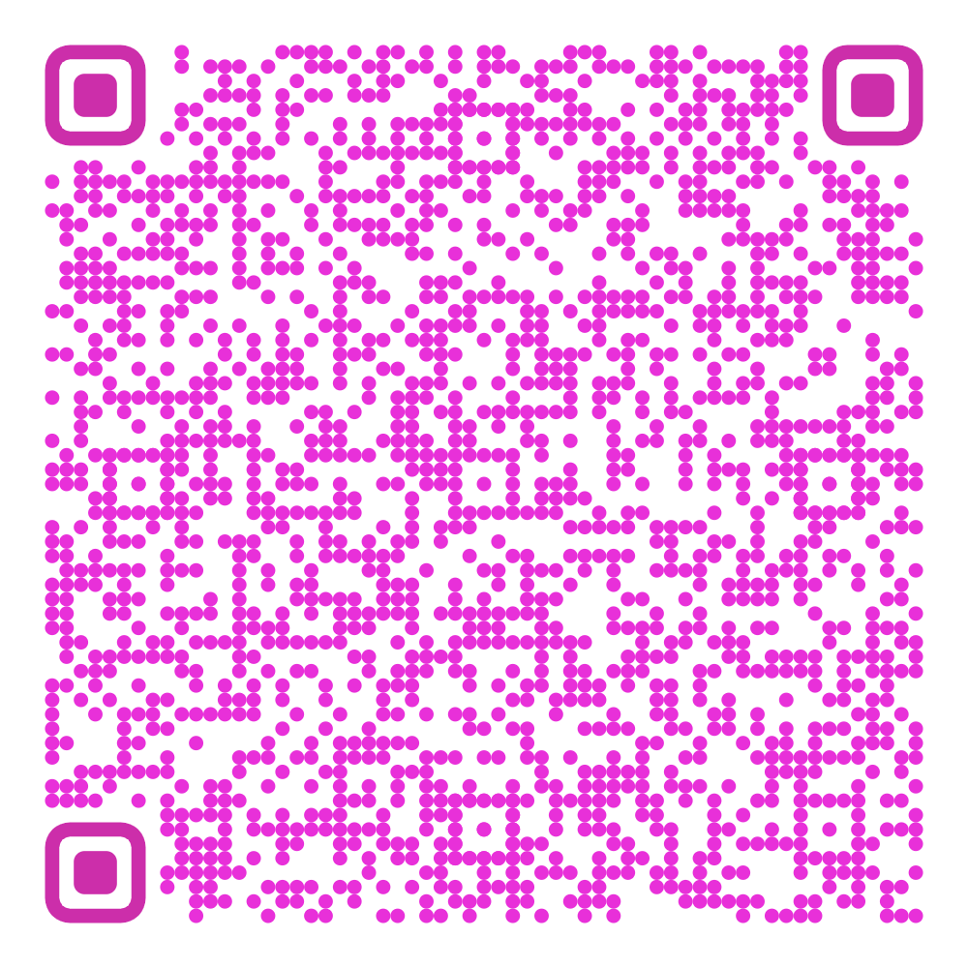
10 | Technology Needs Assessment Report (Adaptation)  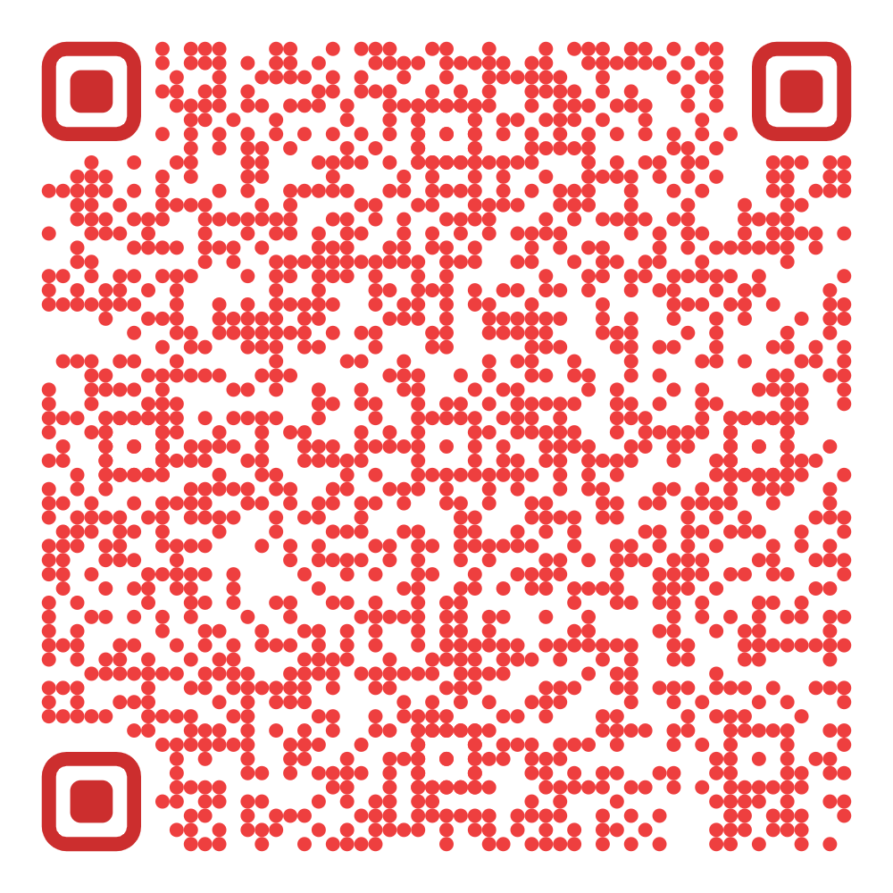
11 | Technology Needs Assessment Report (Mitigation)  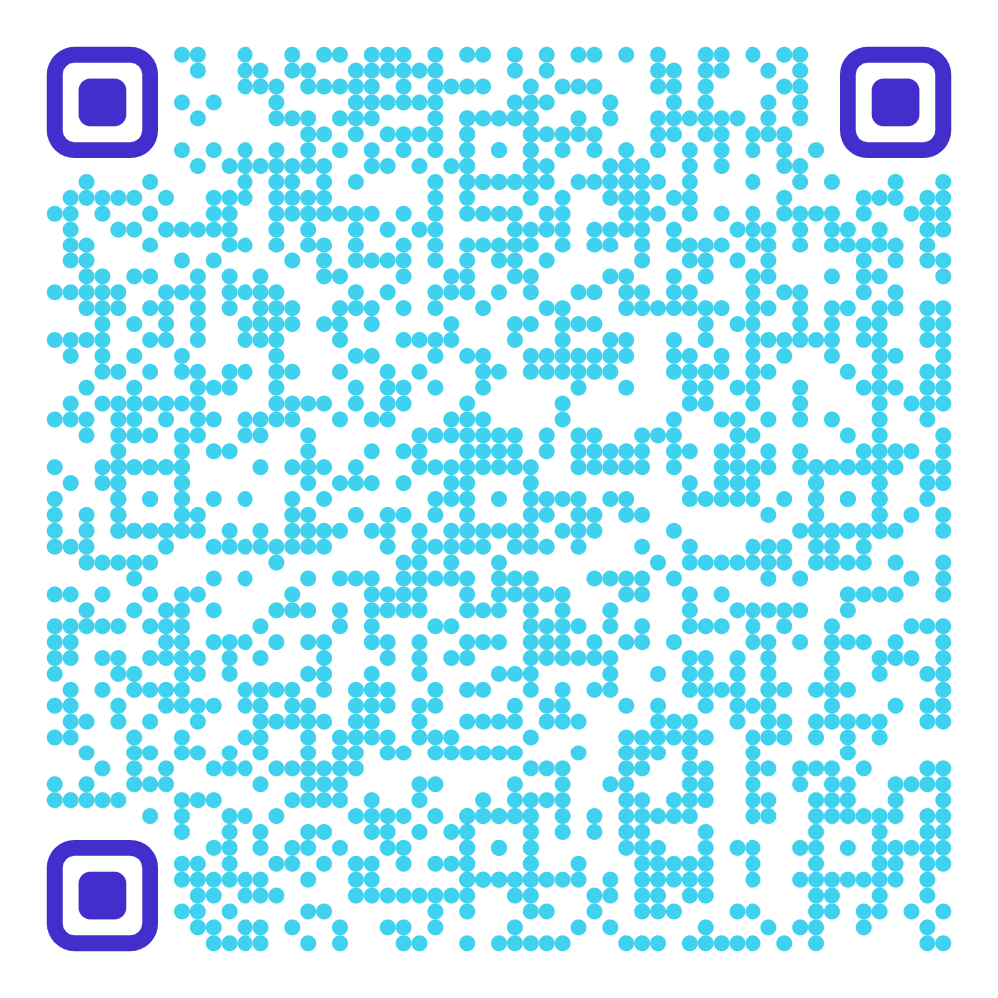
12 | Single-use Plastics (Prohibition) Regulations, 2023  